**LAB 2-DEBUG USING GDB**

**Name:Ramya Ajay**

**Roll No:CB.EN.P2CYS22004**

1.

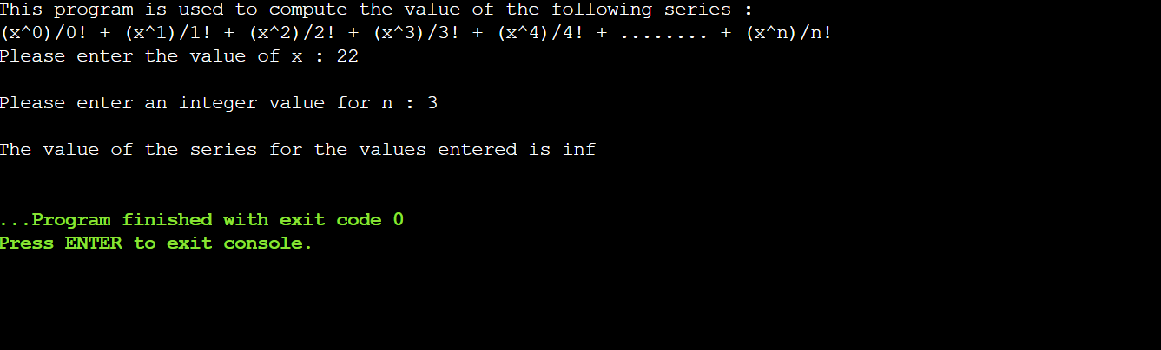

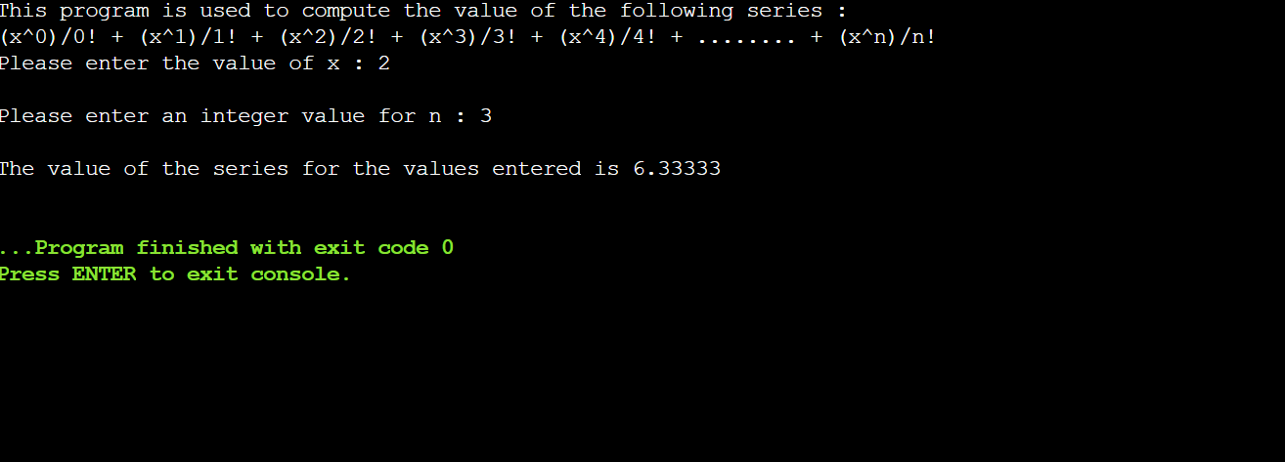

2.

